**Automated Car Catalog System For Enhanced Showroom Management**

# Ideation Phase

## Empathize & Discover

| Date | 31 june 2025 |
| --- | --- |
| Team ID | LTVIP2025TMID28960 |
| Project Name | Automated Car Catalog System For Enhanced Showroom Management |
| Maximum Marks | 4 Marks |

**Mile stone 1.1: Service Catalog**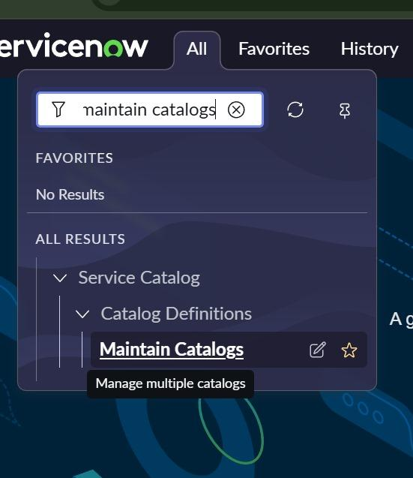

| **Parameter** | **Values** |
| --- | --- |
| **Model Summary** | Navigates to the “Maintain Catalogs” module in ServiceNow under Catalog Definitions. |
| **Category** | Service Catalog > Catalog Definitions |
| **Action Purpose** | Manage multiple catalogs |
| **Search Term Used** | "maintain catalogs" |

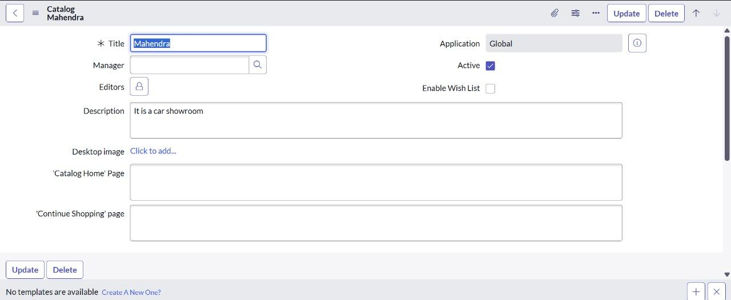

**Mile stone 1.2: Create Categories**

| **Parameter** | **Values** |
| --- | --- |
| **Model Summary** | Catalog item creation in ServiceNow with defined catalog, category, owner, and description. |
| **Item Name** | polo |
| **Catalog** | Mahendra |
| **Category** | Sudden |
| **Owner** | System Administrator |
| **Application Scope** | Global |
| **Active** | Yes |
| **Fulfillment Automation** | Unspecified |
| **Short Description** | "Volkswagen Polo - Compact Hatchback with Superior Comfort and Efficiency." |
| **Tabs Available** | Item Details, Process Engine, Picture, Pricing, Portal Settings |

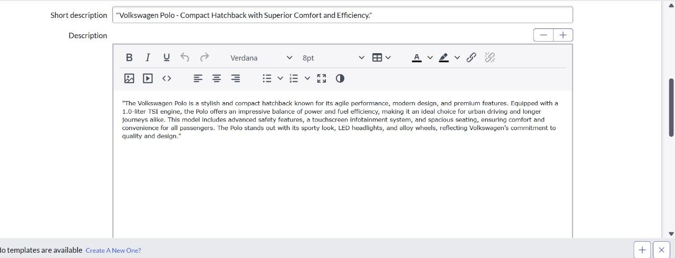

**Mile stone 2: User Creation**

| Parameter | Values |
| --- | --- |
| Model Summary | Creates a user profile in ServiceNow with calendar and time zone preferences set. |
| User ID | 01 |
| First Name | sales person |
| Calendar Integration | Outlook |
| Time Zone | System (America/Los_Angeles) |
| Date Format | System (yyyy-MM-dd) |
| Active | Yes (checked) |

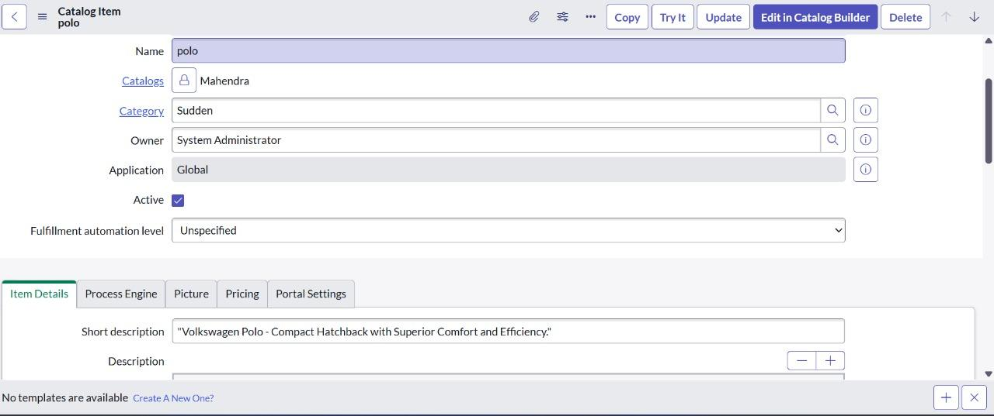

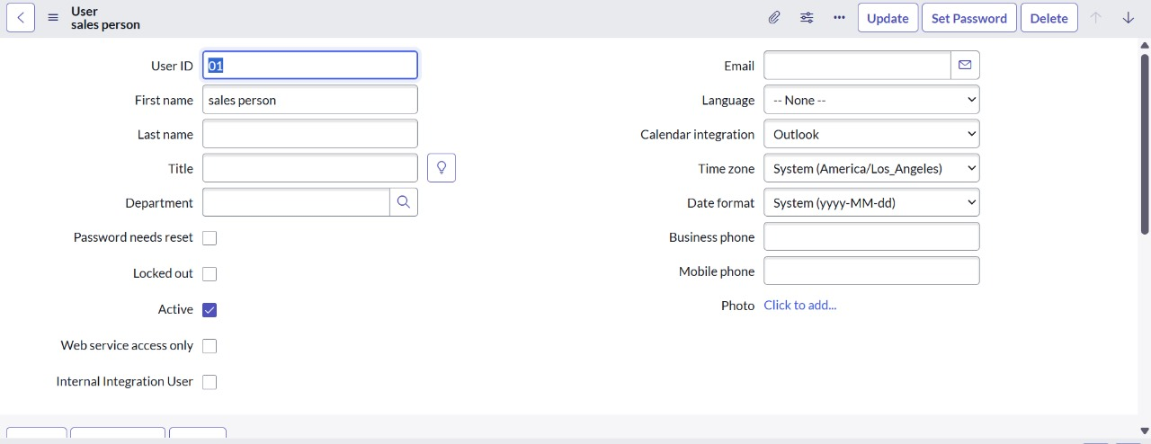

**Mile stone 3:** **Role Creation**

| **Parameter** | **Values** |
| --- | --- |
| **Model Summary** | Creates a new role in the ServiceNow platform. |
| **Role Name** | emp1 |
| **Application Scope** | Global |
| **Elevated Privilege** | No (unchecked) |

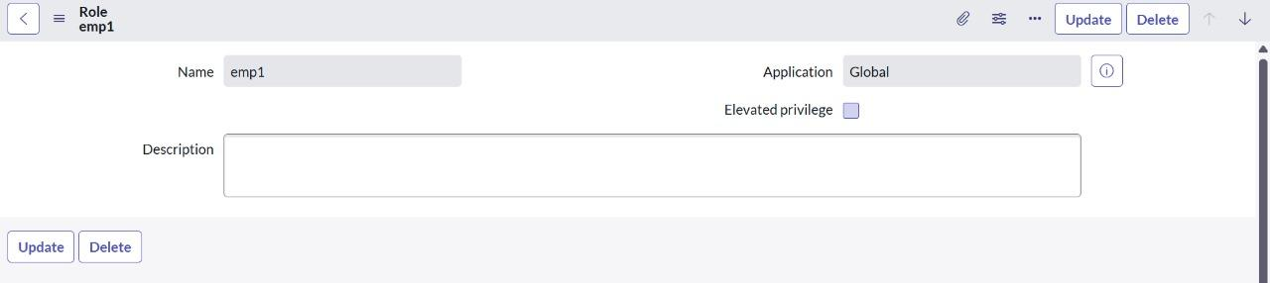

**Mile stone 4:** **Group Creation**

| **Item** | **Details** |
| --- | --- |
| **Catalog Item** | **polo** - Volkswagen Polo, compact hatchback |
| **Catalog** | Mahendra |
| **Category** | Sudden |
| **Owner** | System Administrator |
| **Application** | Global |
| **Status** | Active |
| **User** | **sales person (ID: 01)** |
| **Status** | ✅ Active |
| **Time Zone** | America/Los_Angeles |
| **Calendar** | Outlook |
| **Group** | showroom |

| **Group** | **showroom** |
| --- | --- |
| **Manager** | Abraham Lincoln |
| **Members** | sales person, sales person2, sales person3 |
| **Description** | Car showroom sales team |

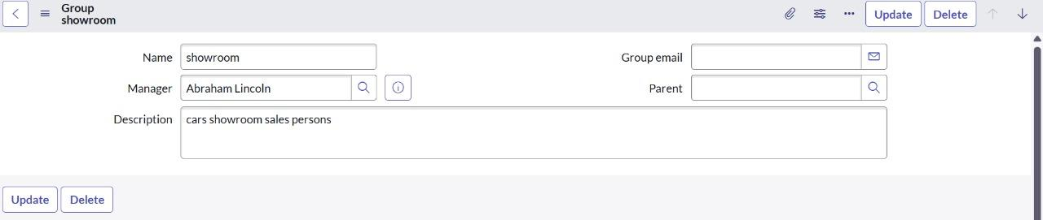

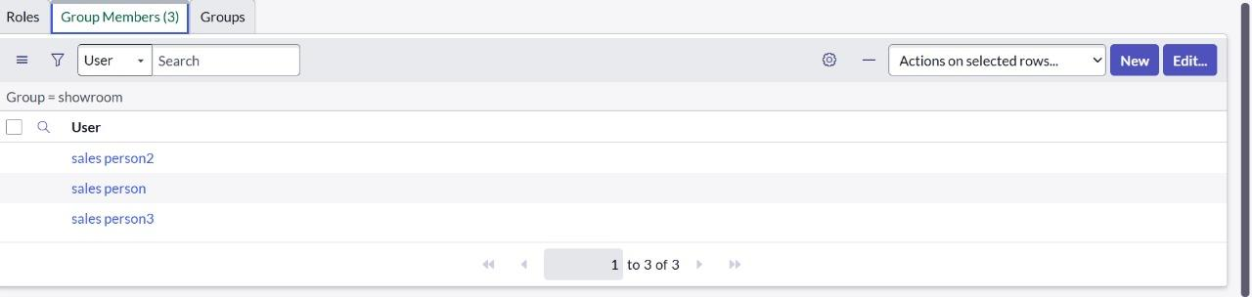

**Mile stone 5:** **Table Creation**

**Catalog Item :**

| **Field** | **Value** |
| --- | --- |
| **Name** | Polo (Volkswagen Polo) |
| **Catalog** | Mahendra |
| **Category** | Sudden |
| **Owner** | System Administrator |
| **Application** | Global |
| **Active** | Yes |

**User :**

| **Field** | **Value** |
| --- | --- |
| **User ID** | 01 |
| **Name** | Sales Person |
| **Calendar Integration** | Outlook |
| **Time Zone** | America/Los_Angeles |
| **Active** | Yes |
| **Group** | showroom |
|  |  |

**Role :**

| **Field** | **Value** |
| --- | --- |
| **Role Name** | emp1 |
| **Application** | Global |
| **Elevated Privilege** | No |

**Group :**

| **Field** | **Value** |
| --- | --- |
| **Name** | showroom |
| **Manager** | Abraham Lincoln |
| **Members** | sales person, sales person2, sales person3 |
| **Description** | Car showroom sales persons |

**Tables (System Definition → Tables) :**

| **Table Name** | **Extends** | **Extensible** | **Updated** |
| --- | --- | --- | --- |
| cmdb_ci_appl_dot_net | Application | No | 2025-04-02 08:47:33 |
| evaluation to evaluation_parameter_result | (empty) | No | 2025-04-02 08:38:38 |
| cmdb_ci_lb_a10 | Load Balancer | No | 2025-04-02 08:47:18 |
| sys_security_acl, sys_security_acl_role | Application File | No | 2025-04-02 08:31:40 |

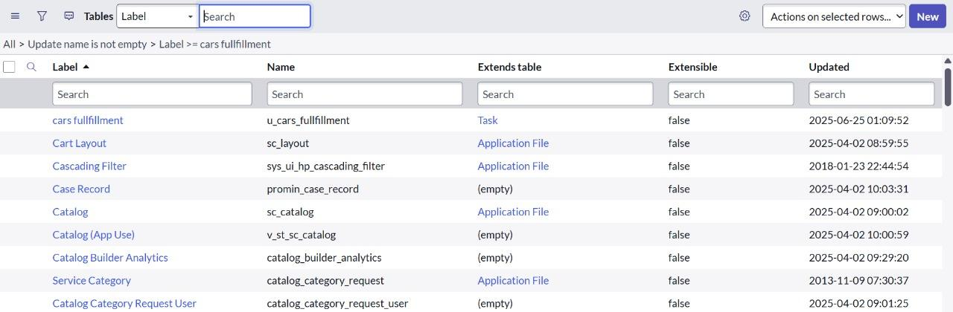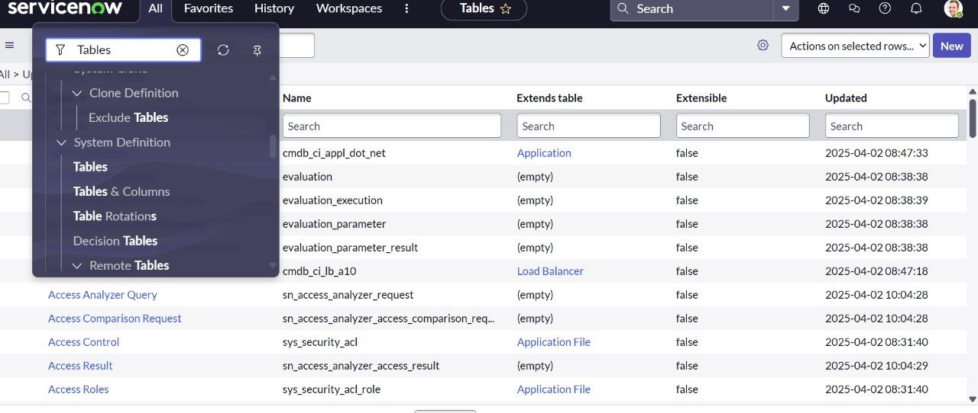

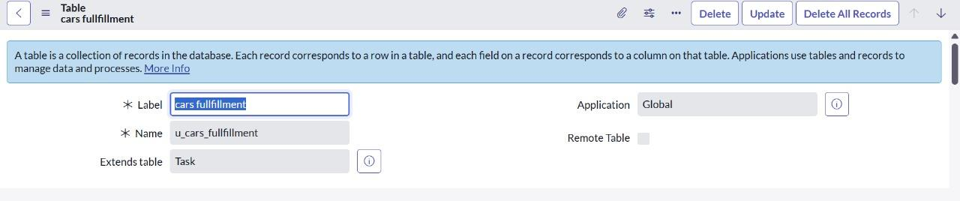

**Mile stone 6:** **Workflow**

| **Field** | **Value** |
| --- | --- |
| **Subject** | car showroom |
| **Message** | car booking approval is rejected |

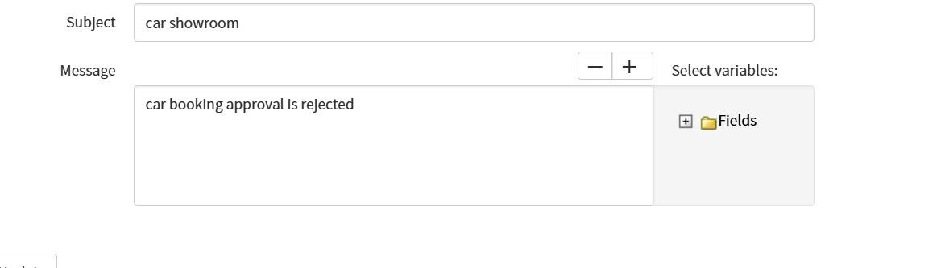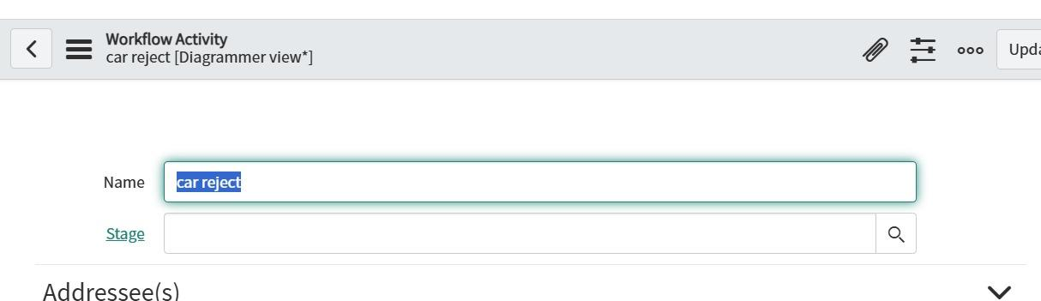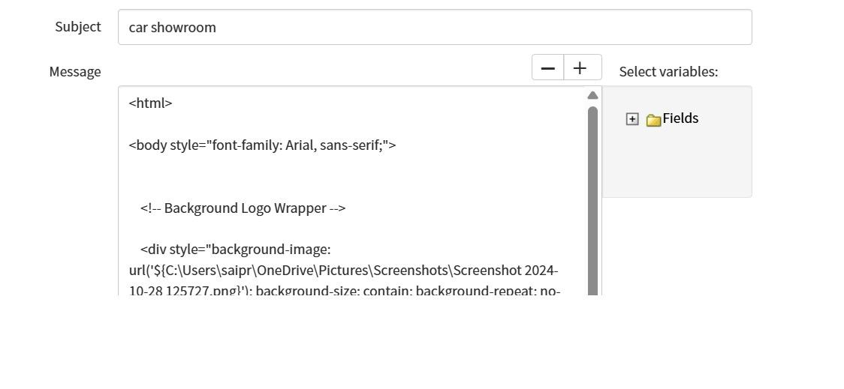

| **Field** | **Value** |
| --- | --- |
| **Subject** | car showroom |
| **Message** | HTML content including custom background, Arial font, and an embedded image (local file reference: Screenshot 2024-10-28 125727.png) |

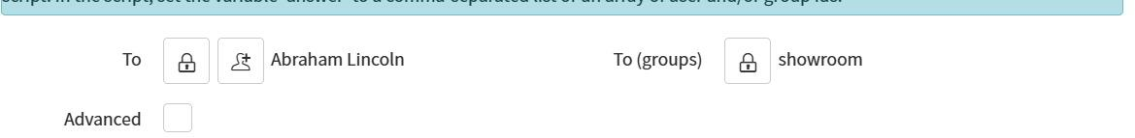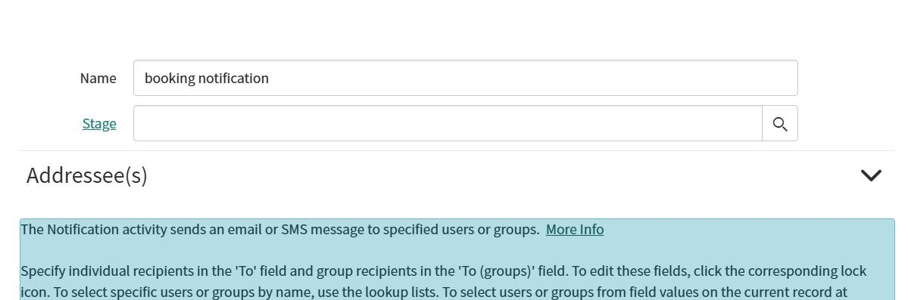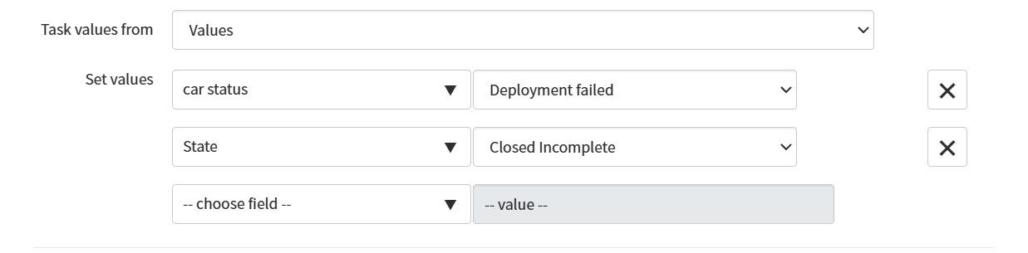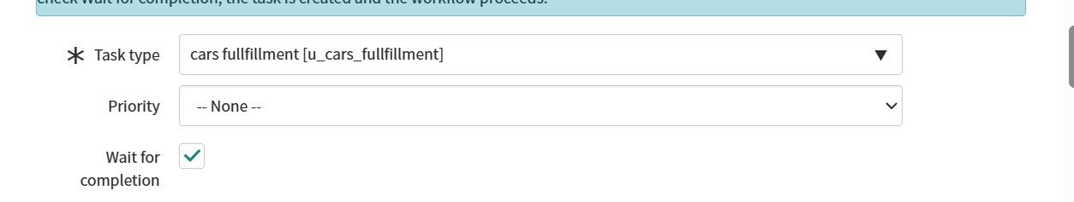

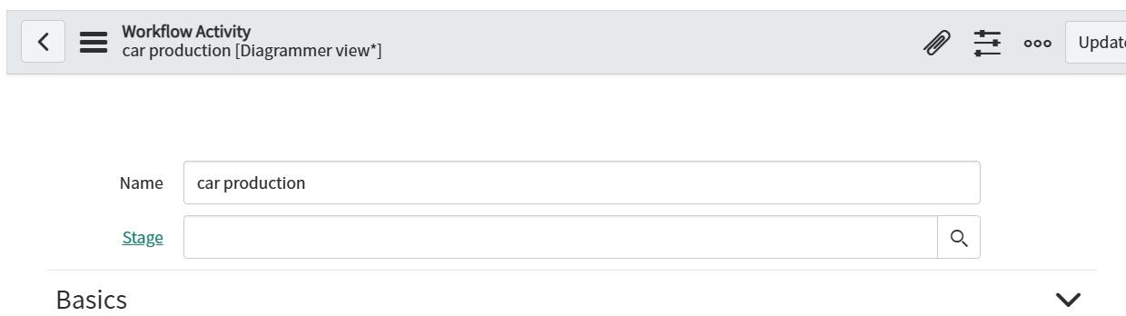

| **Field** | **Value** |
| --- | --- |
| **Name** | showroom |
| **Manager** | Abraham Lincoln |
| **Description** | cars showroom sales persons |
| **Members** | sales person, sales person2, sales person3 |
| Step | Description |
| 1 Begin | Process starts |
| 2️ Sales Approval | User approval (sales) |
| 3️ 2nd Level Approval | Conditional 2nd-level approval |
| If approved | Create Task → car company |
| If approved by sales only | Create Task → car production |
| If rejected | Send Notification → car reject |

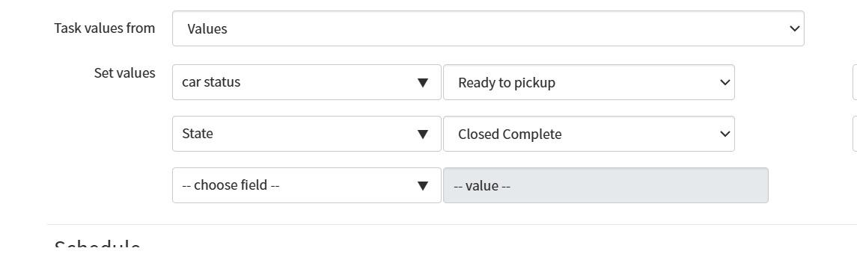

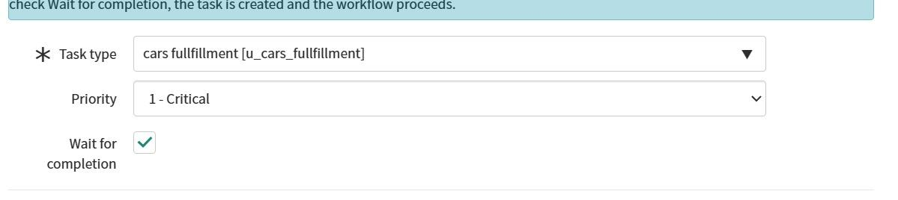

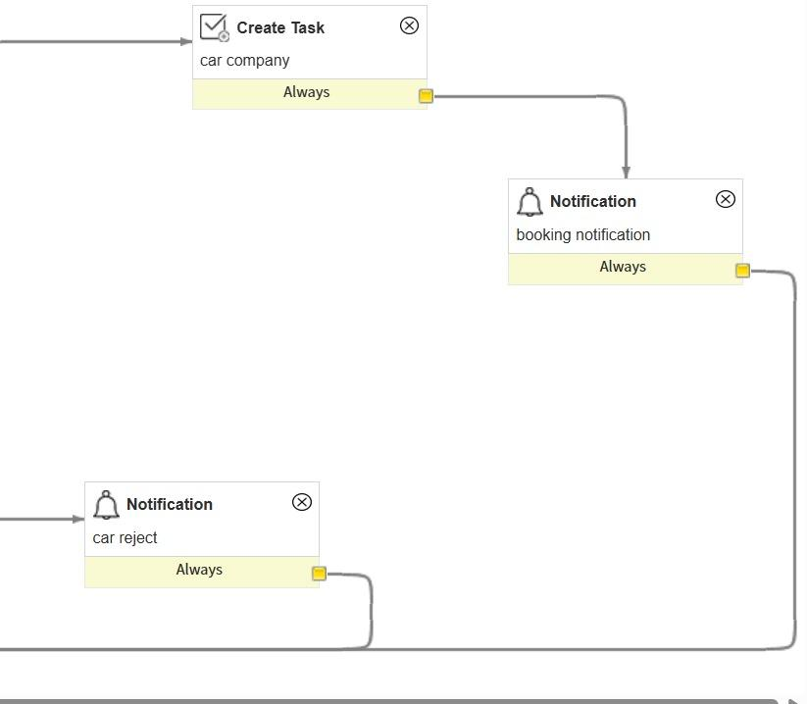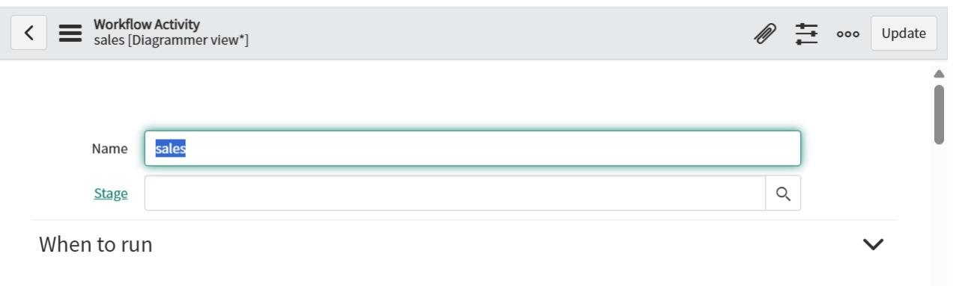

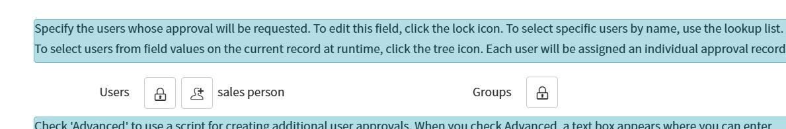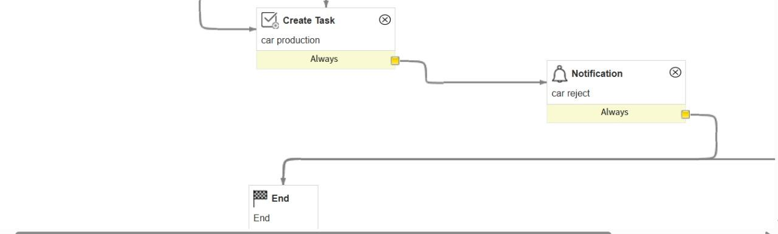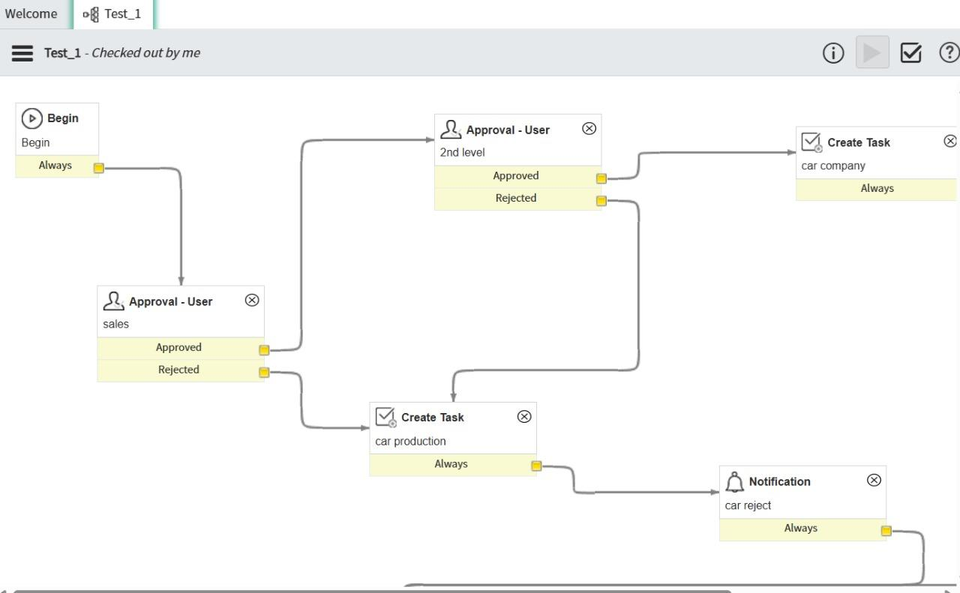

**Mile stone 7:** **service portal**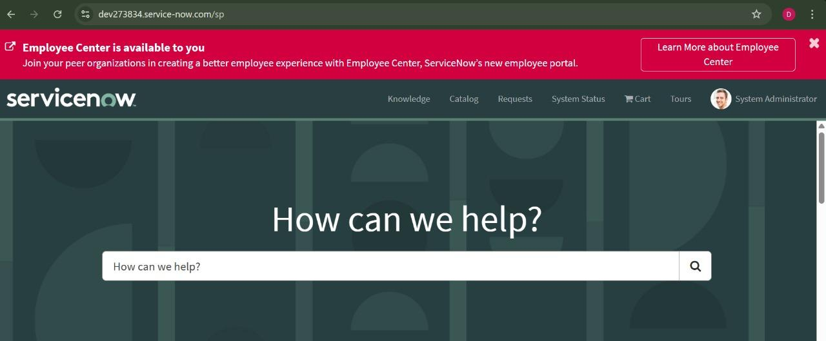

| Field | Value |
| --- | --- |
| Instance | dev273834.service-now.com |
| Portal Type | Service Portal (/sp) |
| User Role | System Administrator (logged in) |
| Notice Bar | Employee Center available (upgrade prompt) |
| **Field** | **Value** |
| **Name** | showroom |
| **Manager** | Abraham Lincoln |
| **Description** | cars showroom sales persons |
| **Members** | sales person, sales person2, sales person3 |

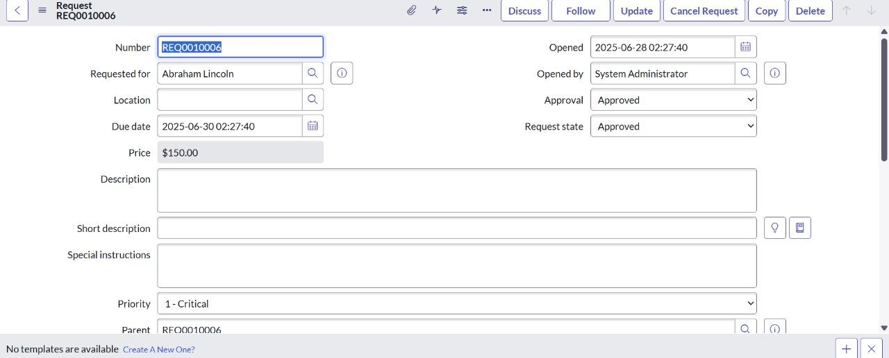

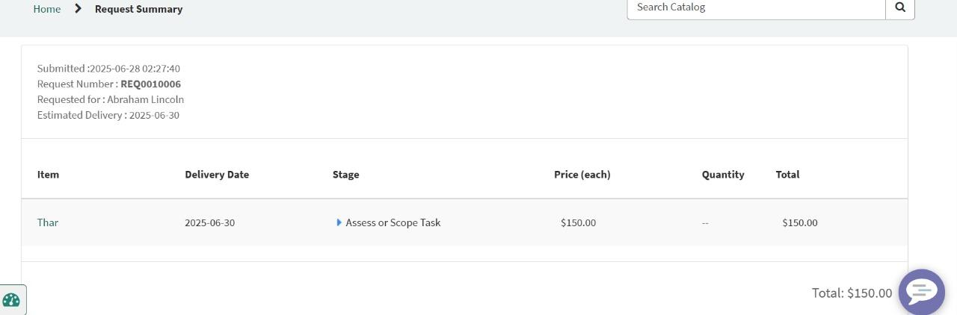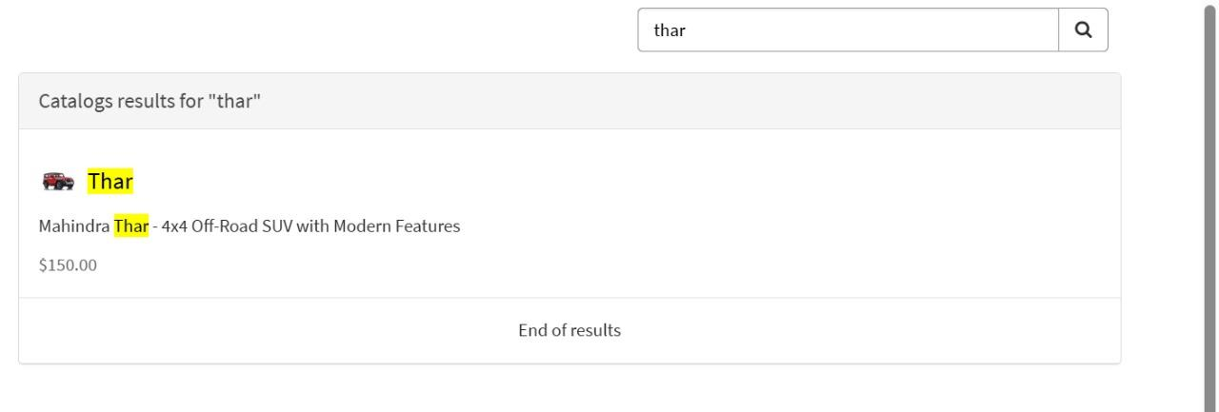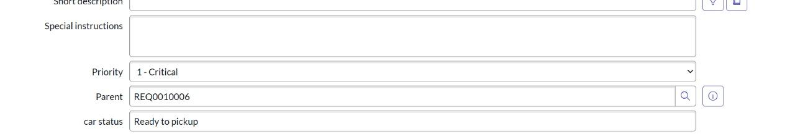

**Mile stone 8:result**

| **Field** | **Value** |
| --- | --- |
| **Name** | showroom |
| **Manager** | Abraham Lincoln |
| **Description** | cars showroom sales persons |
| **Members** | sales person, sales person2, sales person3 |

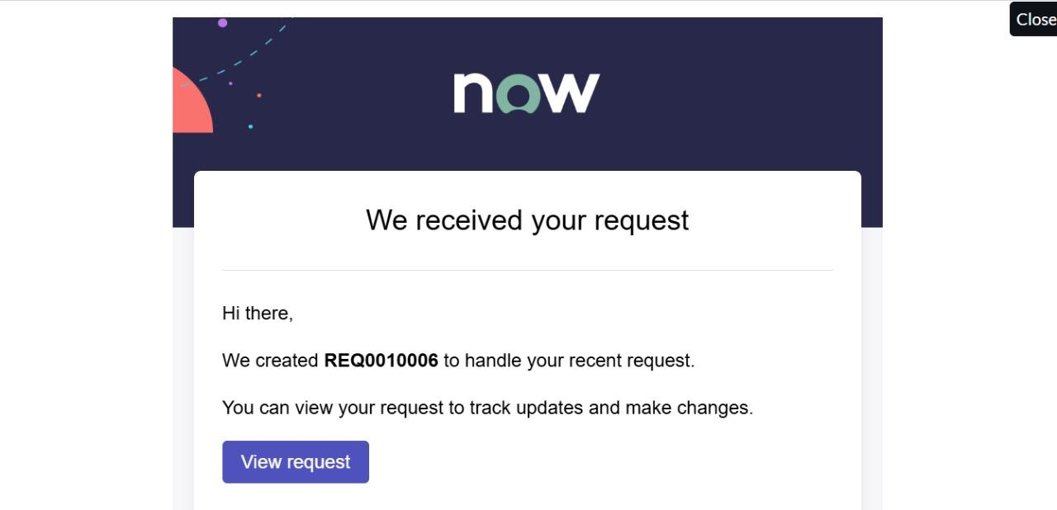

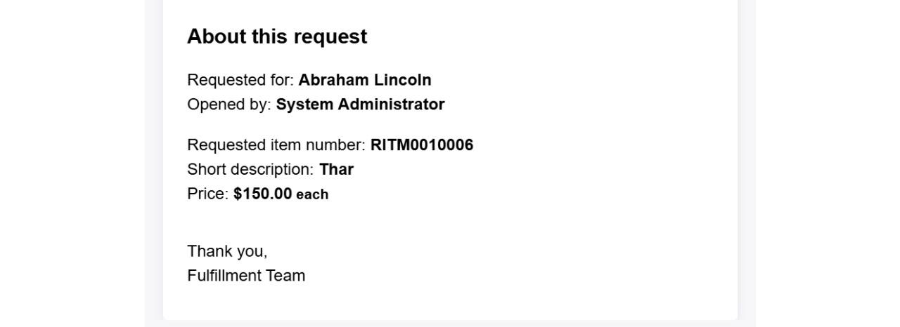

**Conclusion:**

**The Car Catalog System project for a car showroom in ServiceNow successfully addresses the need for a streamlined, automated approach to managing car catalog items, customer requests, and approval workflows. By organizing car models into easily navigable categories and leveraging ServiceNow's powerful automation features, the system enhances operational efficiency, reduces manual intervention, and improves customer satisfaction.**